ELI MAZARIEGOS 201709426  
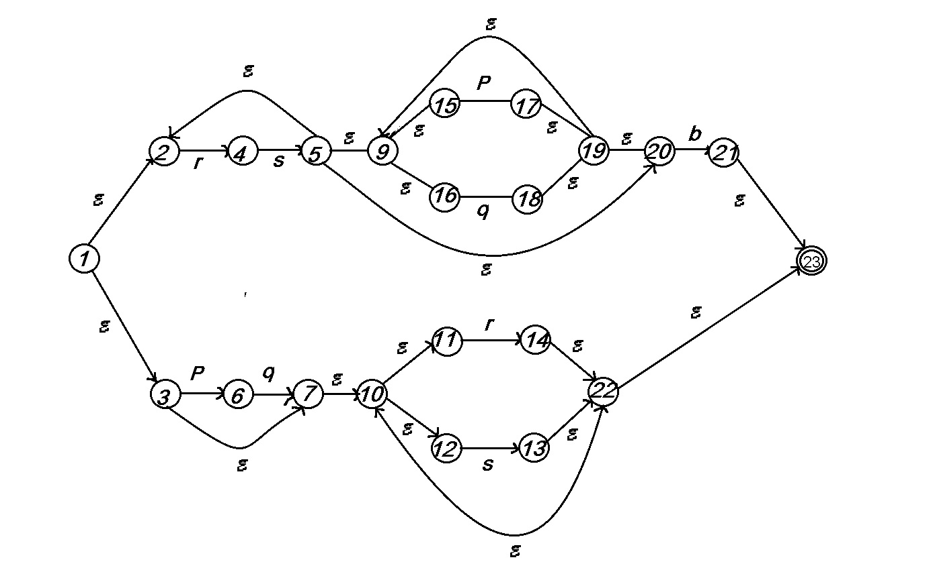

|  |  |  |  |  |  |
| --- | --- | --- | --- | --- | --- |
| Q | E | P | Q | R | S |
| 1 | {2,3} | 0 | 0 | 0 | 0 |
| 2 | 0 | 0 | 0 | 4 | 0 |
| 3 | 7 | 6 | 0 | 0 | 0 |
| 4 | 0 | 0 | 0 | 0 | 5 |
| 5 | {9,20} | 0 | 0 | 0 | 0 |
| 6 | 0 | 0 | 7 | 0 | 0 |
| 7 | 10 | 0 | 0 | 0 | 0 |
| 9 | {15,16} | 0 | 0 | 0 | 0 |
| 10 | {11,12} | 0 | 0 | 0 | 0 |
| 11 | 0 | 0 | 0 | 14 | 0 |
| 12 | 0 | 0 | 0 | 0 | 13 |
| 13 | 22 | 0 | 0 | 0 | 0 |
| 14 | 22 | 0 | 0 | 0 | 0 |
| 15 | 0 | 17 | 0 | 0 | 0 |
| 16 | 0 | 0 | 18 | 0 | 0 |
| 17 | 19 | 0 | 0 | 0 | 0 |
| 18 | 19 | 0 | 0 | 0 | 0 |
| 19 | {20,9} | 0 | 0 | 0 | 0 |
| 20 | 0 | 0 | 0 | 0 | 0 |
| 21 | 23 | 0 | 0 | 0 | 0 |
| 22 | 23 | 0 | 0 | 0 | 0 |
|  |  |  |  |  |  |
|  | C:\Users\Samuel\AppData\Local\Microsoft\Windows\INetCache\Content.Word\IMG_20190317_000935.jpg |  |  |  |  |

